AI Assisted Coding
Assignment 1.2
Name: Sri priya
HT No: 2303A52334
Batch: 31

Task 1:

Prompt:

# Write a Python program to calculate factorial of a number using loops only.Do not use any user-defined functions.

Code & output:
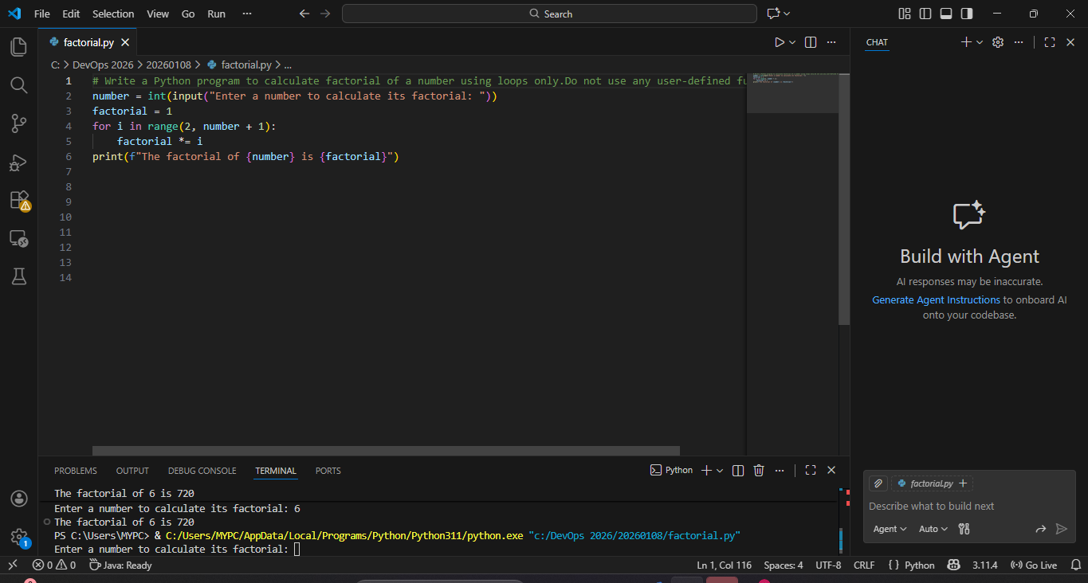

Explanation:

Copilot was very helpful for a beginner as it quickly generated correct logic based on the prompt. It reduced the time required to write the code by suggesting a complete solution. The generated code followed best practices such as input validation and edge case handling. Copilot also helped in avoiding syntax errors and logical mistakes. Overall, it made coding easier & faster

Task 2:

Prompt:

# Write a Python program to calculate factorial of a number using loops only.Do not use any user-defined functions. i want Optimized Code

Code & output:

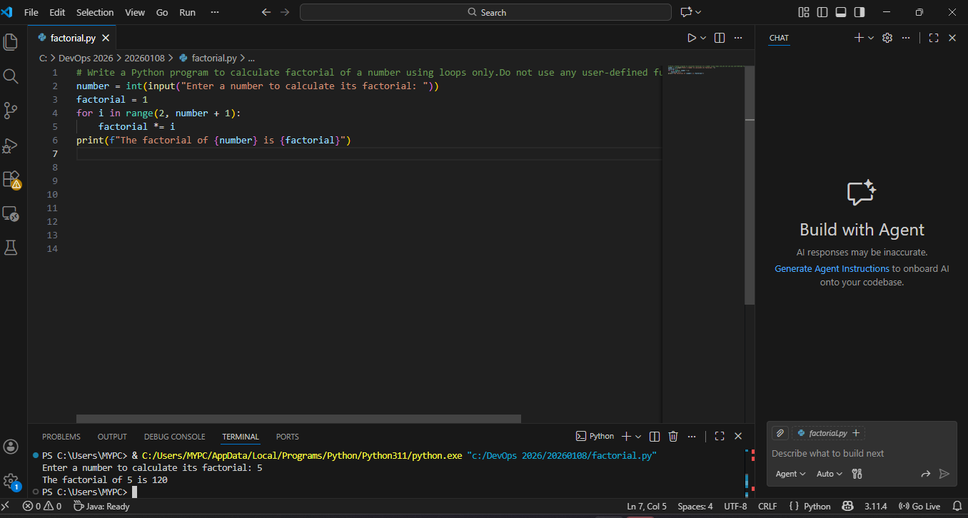

Explanation:

In this task, the code generated in Task 1 was optimized using GitHub Copilot. The AI simplified the loop by starting the iteration from 2 and removed unnecessary operations. Variable usage was kept minimal while maintaining the same output. The optimized code is more readable and efficient

Task 3:

Prompt:

# Write a Python program to calculate factorial of a number using function.

Code & output:

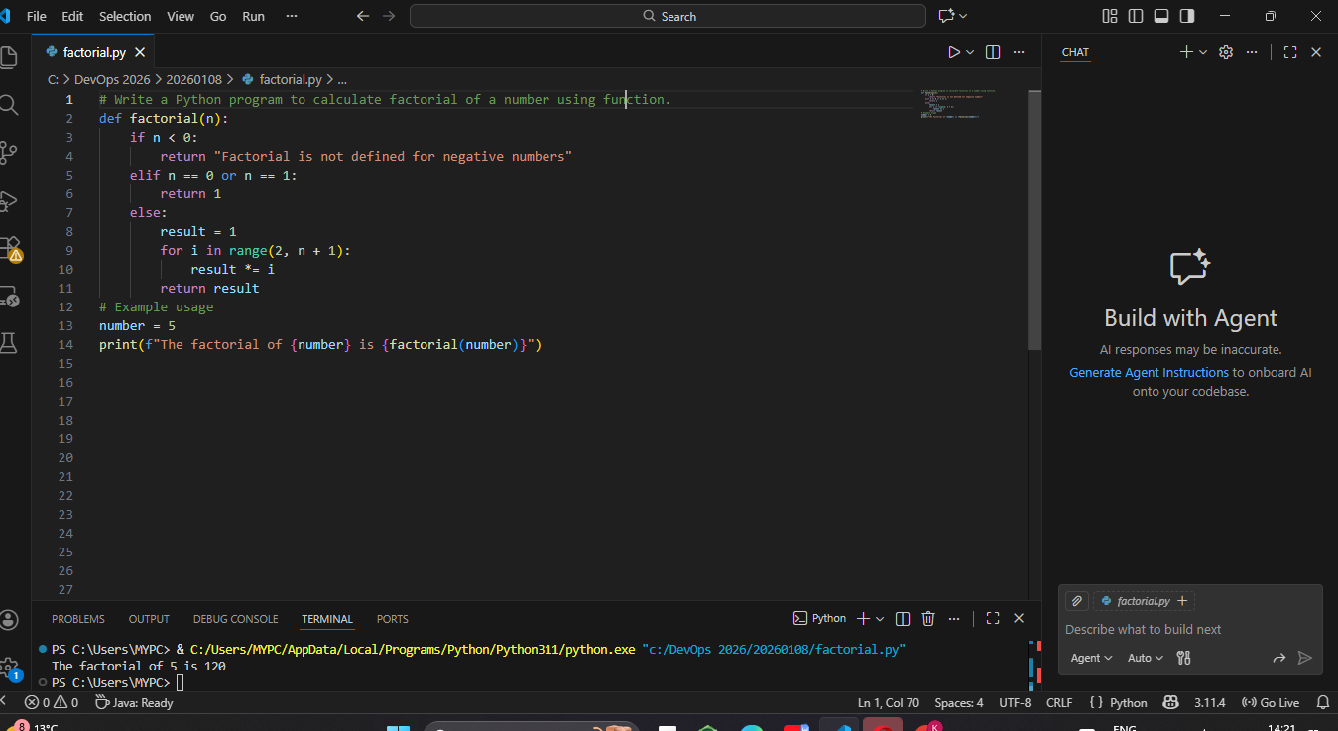

Explanation:

Copilot Modified The Code To Function Type & main block is created Handled Edge Cases Well

Task 4:

criteria | Without Functions | With Functions
Logic Clarity | Medium | High
Re-usability | Low | High
Debugging | Harder | Easier
Scalability | Not suitable | Suitable
AI Dependency Risk | Higher | Lower

Explanation:
This comparison shows that modular programming is more efficient and scalable. While AI can generate both styles, function-based code is preferred in real-world applications due to better structure and reuse.

Task 5:

Prompt1:

# Write a Python program to using iterative approach.

Code & output:

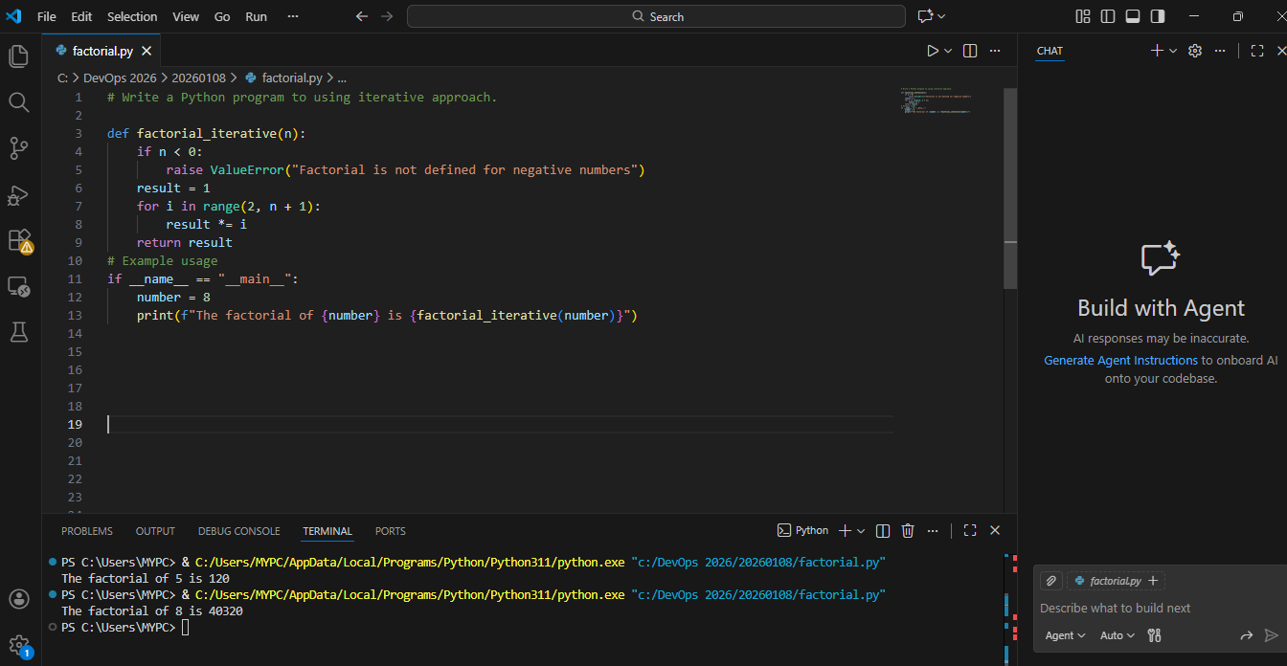

Prompt2:

# Write a Python program to using recursion approach.

Code & output:

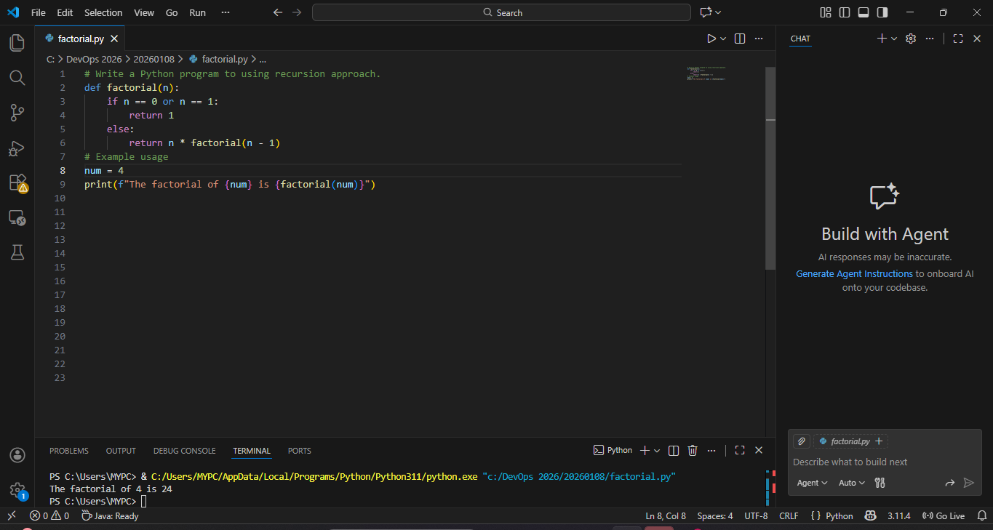

Aspect | Iterative | Recursive
Readability | Simple | Moderate
Stack Usage | Low | High
Performance | Faster | Slower
Risk | Safe | Stack overflow for large n
Recommendation | Preferred | Avoid for large inputs

